Today we’re going to write a report on pollution. Can you help me to finish the passage? Look at the pictures and the words given in the box.

Dangerous land fresh air late problem noise air rubbish serious water roadworks smoke safe

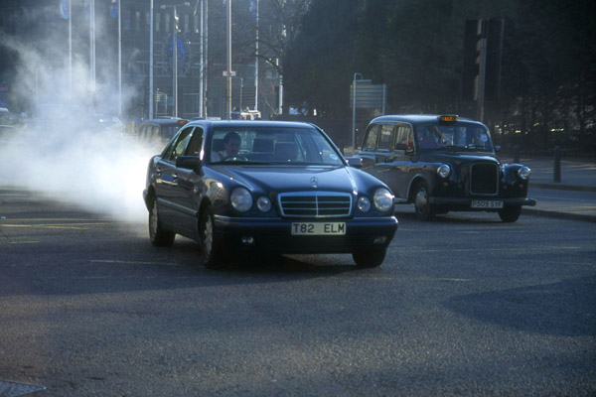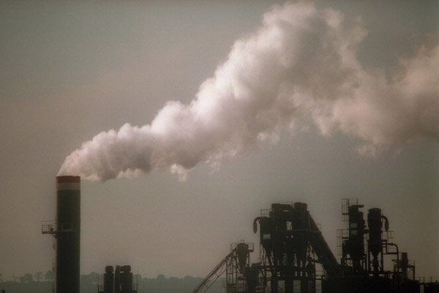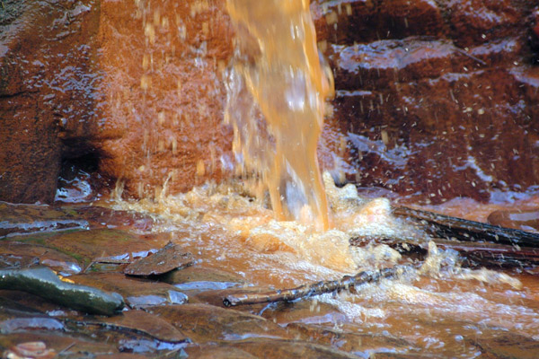

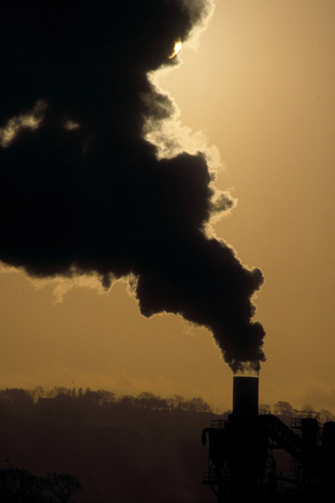 | The pollution in Hong Kong is a ___________ problem.  We have _____________ pollution which makes the rivers and the sea very dirty. Some seafood is no longer ______ to eat now.  We have __________ pollution because of the ________made by cars and factories.  ____________ pollution is also getting worse because of the ________ and traffic in our streets.  If we allow this to go on, Hong Kong will become a ________ place to live in. Therefore we must do something before it is too ______.  If we don’t stop making a lot of smoke, we won’t have _____________ to breathe.

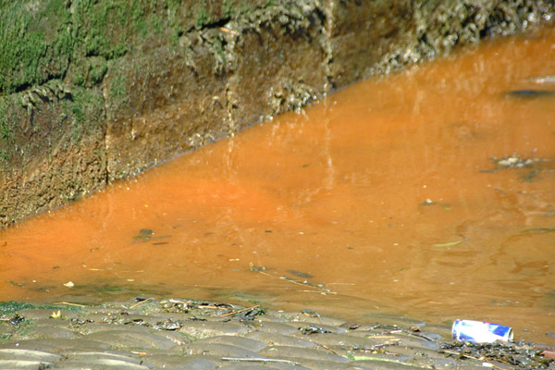

Today we’re going to write a report on pollution. Can you help me to finish the passage? Look at the pictures and the words given in the box.

Dangerous land fresh air late problem noise air rubbish serious water roadworks smoke safe

The pollution in Hong Kong is a serious problem.
We have water pollution which makes the rivers and the sea very dirty. Some seafood is no longer safe to eat now.
We have air pollution because of the smoke made by cars and factories.
Noise pollution is also getting worse because of the roadworks and traffic in our streets.
If we allow this to go on, Hong Kong will become a dangerous place to live in. Therefore we must do something before it is too late.
If we don’t stop making a lot of smoke, we won’t have fresh air to breathe.

