LINGO-ETHNICAL TREE
INTRODUCTION
The purpose of this page is to attempt to show the lingo-genetic relationship of the Türkic people within the human society. The development of the genetical maps, which reflect the statistical values for the pre-1492 populations, opened opportunities for the interpretation of the lingo-ethnical history. In most cases the linguistical map, based on the genetical map, follows a path that is intuitively evident and consistent with the historical data. The reconstructions, based on the linguistical data, converge with the analysis of the genetic data. The linguistic connections parallel those of the measured genetic distance. The genetic trees, showing the estimated time of the separation, indicate the probable time of the dialectical splits and the durations of the independent development. For example, the linguistical diversity of the European peoples is consistent with their position on the genetic map. Some segments of the lingo-genetical family are so consistent with the historical developments that they can be accepted as facts.
The other segments, however, remain controversial and subject to ongoing speculations and interpretations. In such cases the most beneficial is their exclusivity, i.e. the positive indication that certain scenarios are not applicable, contrary to the previous conjectures.
In respect to the Türkic studies, the prevalent thought is considerably influenced by the postulates, established in the 16-th century solely for political purposes. Starting form the pre-Imperial times, the politico-scientific apparatus segregated and contraposed the Eastern European population into two virtual categories. One category is a purebred Slavic variety of the Indo-European group, in the process of repossessing its native Indo-European territories, at the time occupied by the second category, the invading newcomers from Asia. For the purposes of this scheme, Asia is defined not along the historical concept of Asia as a territory extending from Asia Minor in the west and to the east of the Tanais river. Instead, looking from the Moscovite state, Asia and Asiatic is defined as east from the Urals, and extending to the vague space somewhere in the deep East. With such definition of Asia, the presence of the “Asiatic” people in the pristine European lands becomes patently invasive and objectionable from the standpoint of the Indo-European repatriates. Neglected in this concept is the composite structure of the Russian population, with its prevailing Slavicized Finnish and Türkic components.
The continuous infusion of the Indo-European Slavic population into the Türkic masses of the Northern Pontic steppe and forest-steppe belt is documented from the 4-th century. The infusion of the Slavic population into the Finnish population of the Northern Pontic forest zone is documented from the 8-th century. The contemporary Slavicized population has a heterogenic nature of assimilated and intermixed people. Using the contemporary composition as a “baseline” to segregate the Slavicized and non-Slavicized populations makes the division an absurdity. Here the genetic linkage does not support the linguistical association. The linguistics supports the affiliation of the Slavic languages with the Indo-European family, and the genetics shows the essentially autochthonous population with Slavic admixture.
The other aspect of the Asiatic dogma is the Mongoloidness of the Türkic speaking population. This fundamental assumption, never clearly stated, permeated the anthropological and ethnical studies. If it were discarded, most of the racial interpretations of the anthropological and archeological conclusions would be immediately invalidated. The Europoid owners of the Issyk Inscription were attributed to the Iranian Indo-Europeans. The material facts of the studies systematically contradict this notion, frequently necessitating a complicated and convoluted legwork to come to the right conclusions.
The uncomfortable contradiction comes from the general picture of the Türkic speaking population, in spite of its “Asiatic” label, as being essentially Europoid, with Oriental, Central Asiatic, Iberian and Uralic admixture. The more detailed and sophisticated is the analysis, the more evident is the result that as far as the percent of the admixture of the Mongoloid and other components, the ratio is essentially stable and not far different from the contemporary diversity. The persistent discovery of the heterogenic composition among the presumably monogenic newcomers bring about the recurring explanations of the transitional period for the studied group, along a scheme “past purebred Europoids are assimilating the newcoming Mongoloids”. The genetic distance and even incompatibility between the Oriental populations of the Far East and the Türkic populations of the studies demonstrates the weakness of these explanations, invalidating a search for Mongoloidness as inconsistent with the reality. Advocated by a powerful scientific apparatus of the state, the Asiatic concept brought dire consequences to the non-Slavicized Türkic population of the Northern Pontic area.
The Türkic group is prominent by its absence from the lingo-ethnical maps below. The modified graph includes the Türkic group. The graph shows 24 major Türkic languages, omitting a number of languages with a smaller number of speakers, and combining into a single entry languages, usually classified as separate languages for political or geographical considerations. A special case is with the Uzbek language, where its component Kipchak, Karluk and Oguz languages, belonging to the separate branches of the Türkic group, are officially listed as Uzbek dialects. This is analogous to as if a Belgian language listed Flemish and French as Belgian dialects. In the graph, the Kipchak, Karluk and Oguz languages are conditionally shown separately. The affiliation of the extinct Scythian (Assyrian Ishguz), Hunnish, Sumerian, Elamite, Etruscan, Hattic, Urartian, Hurrian, and the living Dravidian and Indo-American languages is no less supported than the affiliation proposed by other theories. The Hungarian language is shown in accordance with the accepted classification, though there are opinions that the classification was politically motivated, and its affiliation with the Altaic group is more appropriate.
In most cases I have a record where the page came from. It is possible that the source site moved or does not exist any more. All pages are accessible from their original source, and no credit is clamed here. Commercial use of these materials may not be made without written permission. The graphs came from the Internet. The major source is the article Genetic Distance and Language Affinities Between Autochthonous Human Populations http://www.friesian.com/trees.htm.
The graphs are mirrored here because they are rare (up until now) illustrations, and they provide a concise visual illustration of the linguistic family tree, essential for the understanding of the current interpretations of the linguistic affiliations. The Graphic Representation Of The Genetic Differences Between 42 Population Groups, http://home.att.net/~eugenics/GeneMap.htm , shows the genetic proximity of the N. Türkic, N. American, C. Amerind, S. American, NaDene, Eskimo, Uralic and Ainu people, closely paralleling and supporting the linguistic association. Even more impressive is the genetic closeness of the Japanese and Koreans to the Türkic genetic group.

Graphic Representation Of The Genetic Differences Between 42 Population Groups
http://home.att.net/~eugenics/GeneMap.htm
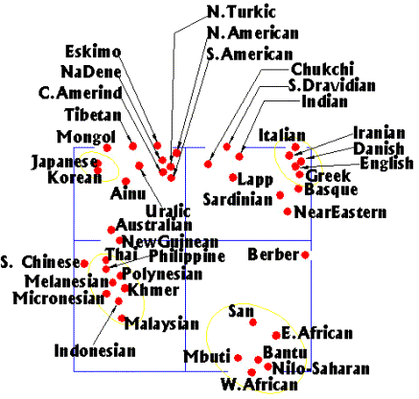

Ural-Altaic, Dravidian, Sumerian Languages
http://www2.4dcomm.com/millenia/lang.htm
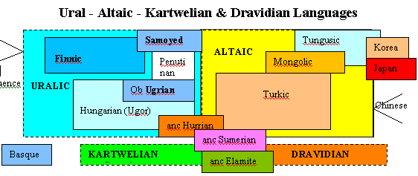

Genetic Distance Between Autochthonous Human Populations
http://www.friesian.com/trees.htm
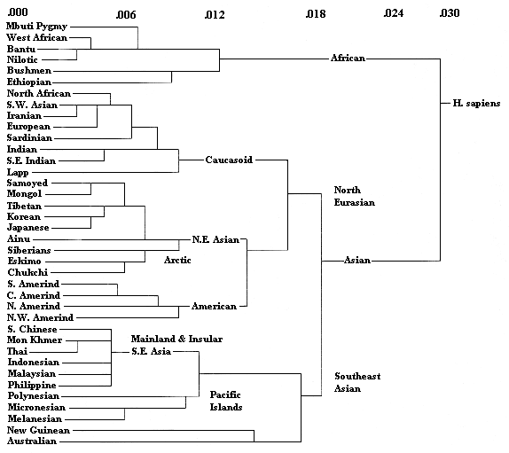

Language Affinities
http://www.friesian.com/trees.htm
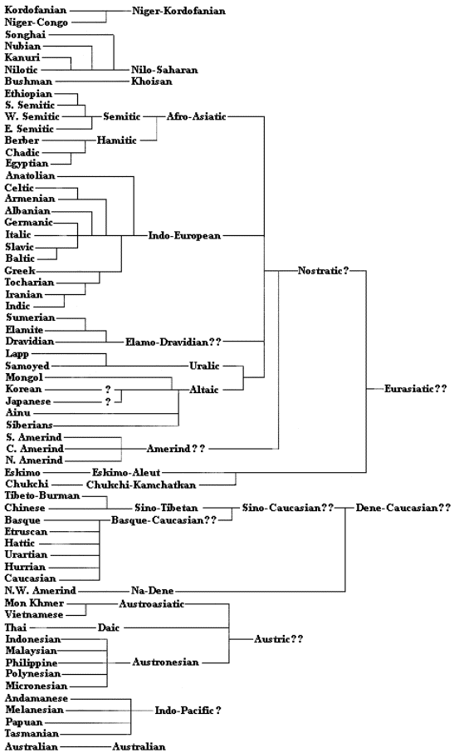
Cavalli-Saforza Genes, Peoples, and Languages [2000]
http://www.friesian.com/trees.htm
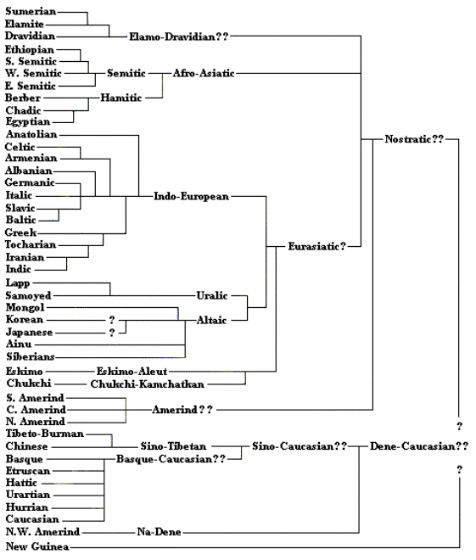

Modified Cavalli-Saforza Language Affinities with expanded Altaic family
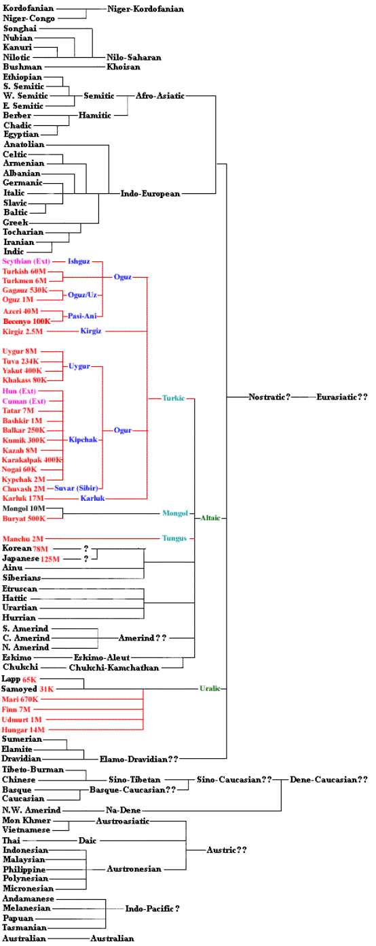
Home  Back  In Russian | Türkic languages  Classification of Türkic languages  Language Types  Türkic and European in Neo- & Mesolith  Türkic and European Genetic distance | Indo-European, Dravidian, and Rigveda  Besenyos, Ogur and Oguz  Scythian Ethnic Affiliation  V.I.Abaev's book as a foundation of the Scythian-Iranian theory  Türkic in English  Türkic, Slavic and Iranian | Türkic in Romance  Alans in Pyrenees  Türkic in Greek  Türkic-Sumerian  Türkic-Etruscan | Alan Dateline  Avar Dateline  Besenyo Dateline  Bulgar Dateline | Huns Dateline  Karluk Dateline  Kipchak Dateline  Sabir Dateline

Contents  Türkic languages | ·  · |  | Содержание  Тюркские языки
Classifications of the Türkic languages
A.N. Samoilovich Classification, 1922
Swadesh List Summary for the Türkic languages
Lingo-Ethnical Tree
Türkic language аnd European genetic distance
Statistical Linguistics. Phonetical and Semantical Concurrence
Türkic borrowings in English
Türkic in Romance
Alans in Pyrenees
Türkic in Greek
Türkic-Sumerian
Türkic-Etruscan
Dictionary of 461 Ancient Türkic Words in 13 Languages
Dictionary of 1,819 Words in 13 Türkic Languages
Ancient Türkic toponymy in Middle Asia

