Besenov, Slovakia Page

Other names: Bešeňov,Besenyo,Besenyö
World:Slovakia
Latitude | 48.0500 | Longitude | 18.2667 | Altitude (feet) | 416
Lat (DMS) | 48° 2' 60N | Long (DMS) | 18° 16' 0E | Altitude (meters) | 126
 | Time zone (est) | UTC+1(+2DT)
Approximate population for 7 km radius from this point: 11320
Google links for Besenov |  |  | Google links for Besenov, Slovakia
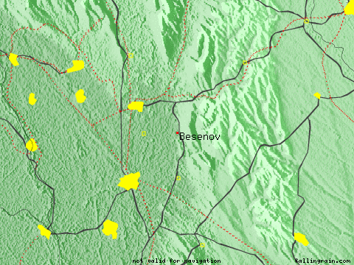
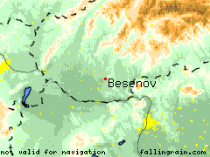 |  |  | 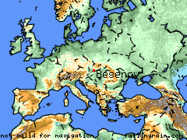
Nearby Cities and Towns
West | North | East | South
Banov (2.7 nm) | Dolny Ohaj (2.1 nm)  Hul (3.0 nm)  Radava (3.3 nm) | Branovo (1.7 nm)  Vel'ka Dolina (1.3 nm) | Dvorsky Majer (2.0 nm)

Nearby airports:
Code | IATA | Name | City | Distance | Bearing | Airlines
FR2927 |  | CSAKVAR |  | 42 nm S | 171
LHPR |  | GYOR PER |  | 31 nm S | 216
LZPP | PZY | PIESTANY |  | 38 nm N | 333 | Unlikely
LZTN |  | TRENCIN |  | 50 nm N | 347

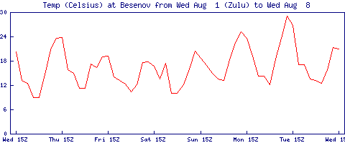
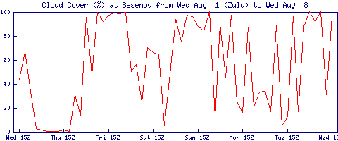
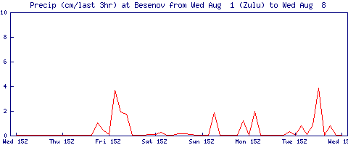

If this page is useful to you, please link to it.
Presentation Copyright © Falling Rain Genomics, Inc. 1996-2004

