Competition rules are not created for this event but these are the general rules of each sport. On the other hand just because of the special character of this contest some parts of the rules can not be adapted. These differences can be found in each call for entries of each event on the official website of the contest.
www.mudi-viadal.atw.hu
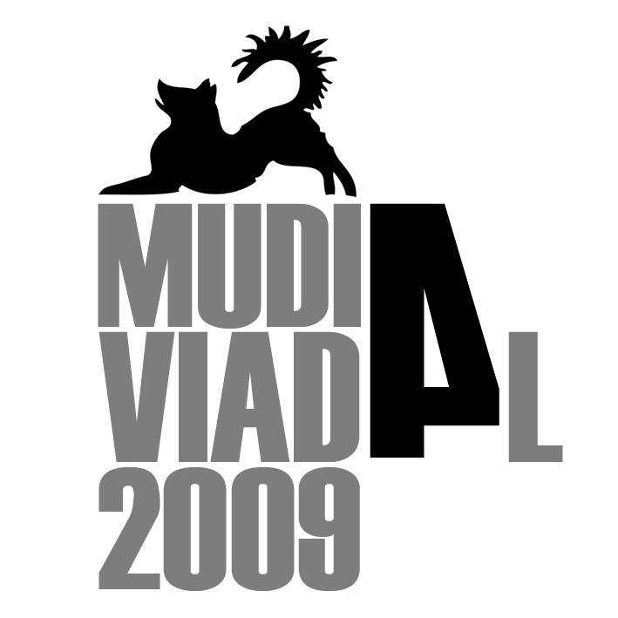

dog dancing competition rules

General Rules
- Every dog with and without pedigree can take part in any Dogdance-Competition and achieve granted status (champion, etc).
- Every person can take part in Dogdance-Competitions regardless of age or (dis-)abilities!
- There is no membership in a club or organisation required!
- The purpose of any dog dance performance is to showcase the team’s and especially the dog’s mental and physical qualities the most appropriate and positive style.
- Every dog and every person can do form a Dogdance team and perform their routine together!
- The focus of the performance should be on the dog and it’s qualities should be portrayed.
- The use of slightly decorated collars is allowed, harnesses and any sort of halters (Halti, Gentle Leader or similar) and other decorations or training aids have to be removed prior to the routine.
- The dog can be led into the ring on a lead and collar, harness or halter, but they need to be removed prior to the start of the routine.
- There is no further decoration of the dog allowed!
- The person should be dressed adequately; a costume can help to enhance the interpretation of the theme.
- The following punitive equipment (Pinch, Choke, Electric collars) are not tolerated at the competition, neither will unfair treatment of the dog accepted.
- Prior to the official Classes there are no primary reinforcers (food, toys, etc) allowed in the competition ring, in during the training times secondary reinforcers and training tools (Clicker, Targets, etc) can be taken into the competition ring.
- The primary reinforcers (rewards) need to be left and given to the dog outside the competition ring at all times!
- If the organiser provides a separate training and warm-up area all reinforcers (primary and secondary) can be used in that area.
- Prior and in all fun classes the use of any training aid and reinforcers is allowed.
- The achieved results in any of the classes (official and fun) will be recorded on a page of achievement. This booklet of achievements should be handed to the organiser in the morning together with the music. The organiser will provide new handlers with those booklets.

Organiser
- The organiser should if possible declare the flooring in the invitation.
- The organiser can but does not have to offer all classes (official and fun).
- The fun classes should be held after the official classes if possible to prevent distractions through food in the ring. If this is not possible the ring should be cleaned prior to the start of the official classes.
- If there are more than 20 entries in one class, the class should be split into two and the two classes should be marked as two separate classes.
- The splitting of a class should be done by the date the entry form is received.
- A Ringsteward has to make sure that everything in and around the ring goes according to plan. He sends the teams into the ring and makes sure that the competitors and spectators comply to the rules.
- The ideal number of judges for each class is three.
- If there are less than 30 routines there can be only two judges.
- If there are more than 45 routines it would be ideal to have a reserve-judge so the judges can rotate after each class. If this is not possible the organiser needs to make sure that there are enough breaks between the classes.
- The points achieved in any of the official classes should be averaged and handed to the competitors after the competition.
- The written notes for the participants of the fun classes should be handed out to the competitors too.
- The results of the competitors have to be stated into the booklet of achievements.
- The organiser should provide new booklets of achievement for new competitors.

Ring
- The floor in the ring should be as dog friendly as possible and should be non-slip.
- The ring should be clearly fenced and if possible opaque.
- If possible there should be a space between the ring borders and the first row of spectators.
- There should be no dogs in the first row around the ring.
- There should be no food in the first row around the ring.

Judges
- The decisions of the judges are final and cannot be challenged by the competitors.
- The competitors accept that although the judges will judge with maximum care the decisions will always be subjective to a certain extent.
- To jugde a Dogdance Compeition at least two of the following criteria need to be met by the jugde:
  - Participation at a competition with his own dog (at least class 2)
  - Participation at a judges workshop
  - At least one time shadow judging
- Judges that have been judging so far can continue judging without further criterias.
- As soon as the number of active judges reaches 20 If there are more than 20 active judges per country the judges criteria should be discussed again.

Classes
At each competition there can be run Official and / or Fun Classes.

Official Classes
- The official classes will be judged by the criterias following in these rules.
- The Competitors will be jugded by points.
- The minimum age for a dog to be eligible for any official class is 12 month on the day of the competition.
- At no time in the official classes are primary or secondary reinforcers (food, toys, clickers, targets, etc) allowed in the ring.
- Those training aids can be left outside the ring and can be given to the dog after the dog has left the ring routine again and only outside the ring!
- The dog shall not carry a prop out of the ring as it could be seen as a reward which would lead to disqualification.
- The organiser can offer classes Trio and Quartet either as an official or as a fun class or both.
- If the numbers of participants in the classes are getting bigger in the future the initiation of a Level 4 could be discussed.
Class 1 | (used to be called Beginners, S-Class)
Class 2 | (used to be called Novice, M-Class)
Class 3 | (used to be called Advanced, L-Class)
Class Trio | (1 Person with 2 dogs)
Class Quartett | (2 Persons with 2 dogs)
Class Juniors | (Teenagers up to the age of 16)

Rules to enter and move up between classes
- These rules are valid until the next convention May 2007 when they will be reviewed and discussed if changes would be required.
- The rules to enter and move up a class apply to the dog.
- Any dog entered prior to the first of June 2006 in a Dogdance-Competition can stay in the class he had been entered but from there on he has to comply with the rules of moving up.

Entries of classes
- Every new dog entered for the first time in an official class has to enter in class 1.
- Exceptions can be made for foreign teams, which have been competing under other rules.
  - The first time, those handlers can enter a class, which they feel eligible.
  - Afterwards, their result will be stated in the record booklet and from then on the rules to move up will apply.

Moving up
- Every team can collect moving-up points.
  - If a team receives his first moving-up point, the team can move up into the next higher class.
  - If a team receives his third moving-up point, the team has to move up into the next higher class.
- Moving-up points will be given to all handlers, receiving 70% or more points of the maximum points in their class.
- The points of the winner in each class is 100%
Example:
1. Place 180 points = 100 %
2. Place 125 points = 70% Enoguh points for moving up.
3. Place 110 points = 60% Not enoguh points for moving up.

Record booklet
- The record booklet is for one team handler and dog.
- Only competitions run and judged under the Offical European rules will be recorded in the booklet.
- If two handlers compete with the same dog, they will need two separate record booklets and can therefore also enter in two different classes with the two handlers.

Fun classes
- There is no judging by points in the fun classes. But the judges will give some written feedback meant as constructive criticism.
- The organiser can but does not need to offer all fun classes.
- The list of fun classes is not finished the organiser can invent further fun classes.
- The use of motivation (food, toys. etc.) and training tools (clickers, tartgets, etc.) is allowed in all fun classes.
- Every team can enter fun classes as often as they wish, this also applies for any dog entered in official classes.
- Dogs from the age of 6 month on the day of competition can enter in the fun classes, although certain moves (jumps, crawl, any move standing on hind legs and any backward move) are forbidden up to the age of 12 months.

Prebeginners | (for dogs entered the first time at a competition)
Seniors | (for dogs older than 8 years and / or handlers over 60 years)
Trio | (1 handlers with 2 dogs)
Quartett | (2 handlers with 2 dogs)
Gruppen | (more than 2 handlers with more than 2 dogs)
Lucky Dip | (The music will be drawn in the morning and the team has to improvise to it)
Fun Class | (everything goes)
Free Choice | (The organiser can invent further fun classes)

Music Lengths

Official classes
Class 1 | 1:15 - 2:00
Class 2 | 1:45 - 2:30
Class 3 | 2:15 - 3:30
Class Trio | 1:30 - 3:00
Class Quartett | 1:30 - 3:00
Class Juniors | 1:15 - 2:15

Time faults in the official classes
- There is no tolerance in the above music lenghts!
- The time displayed on the CD-Player is binding.
- Per second overtime or shortage 1 point will bededucted.
- The DJ checks the music lengths and informs the judges about overtime or shortage.
Fun classes
Prebeginners | Maximum 2:00
Fun class | Music length is not specified (max. 3:30)
Seniors | Maximum 2:30
Trio | 1:30 - 3:00
Quartett | 1:30 - 3:00
Groups | 1:30 - 4:00
Lucky Dip | Music length is not specified (max. 3:30)

Marks

Artistic Impression (max. 100 Points)

Choreography - max. 25 Points
- Development of the routine, structure, etc.
- Transitions of moves and sequences
- Ring use and layout of the routine

Dynamism - max. 25 Points
- Animation & Motivation in relation to the concept
- Harmony of movements, timing and interaction
- Interaction Dog-Handler

Concept - max. 25 Points
- Expressions of emotions, theme, a story, etc.
- Creativity in the realisation

Rhythm - max. 25 Points
- Dancing in the rhythm in relation to the music style and song
- Rhythmic variations of movements and tempi

Technical Merit (max. 100 Points)

Execution - max. 25 Points
- Accuracy of movements in relation to breed, size, etc of the dog
- Signalling (Signalgebung (desired: hardly noticeable - integrated in the dance; undesired loud, lure moves, etc)
- Attitude & Attention

Flow - max. 25 Points
- Visual harmony of movements, positions and speed
- Use of transisions
- Consistency of execution

Content - max. 25 Points
- Number of moves / combinations / variations
- Balance & Symmetry of directions, positions, etc

Difficulty -max. 25 Points
- Difficulty of execution, difficulty of moves
- Difficulty of signalling & interactions between dog and handler

Deductions

Barking
- A maximum of 20 points in total can be deducted for excessive barking.

Physical manipulation and aggressive commands
- Up to 60 points in total can be deducted for physical manipulation or aggressive comand giving.
- 4 Points will be deducted for each incident!

Improper use of costumes and/or props
Explanation: Props and costume need to be in relation to the concept of the routine and the music and should be used to enhance the presentation. They should not be used only to lure and/or create moves.
- Up to 30 points in total can be deducted for improper use of costume/props.
- Using a prop only to lure or induce moves will result in points being deducted
- There should be a relation between the choreography and the prop(s) and/or costume.
- Every prop carried into the ring has to be used appropriate in the choreography
- It should be clearly visible that the handler is in control when dog engages with the props.

Music overtime or shortage
- Per second over- or undertime one point will be deducted.

Disqualifications
A disqualification needs to be an unanimous decision of all judges. The disqualification is not impugnable!
After a disqualification the team is allowed to finish their routine as a trainingsround. But in officinal classes, no food is allowed in the ring!

Leaving the ring
- All four paws of the dog need to stay in the ring at any time. If the dog passes the line with one paw, he will be disqualified.
- With a line at the entrance and exit of the ring, this rule can be controlled by the ringsteward.
- On the line will count as in the ring.
- In case of doubt the decision should be made in favour of the team.
- The ringsteward has to control the line.

Use of training aids in an official class.
- A training aid can be (list not closed):
  - Primary reinforcers: Food, toys, etc.
  - Secondary reinforcers: Clicker
  - Training aids: Targetsticks, Targets, etc.

Carrying too many props into the ring
- There are only as many props allowed as the handler can carry into the ring by himself!

Soiling in the ring

Unfair treatment of the dog
- Unnecessary pressure, punishments or similar behaviours from the handler will not be tolerated! What falls into this category is at the discretion of the perception of the judges.

Help from outside
- After ring clearance by the steward only the next team is allowed to enter the ring.
- Any help from outside will lead to disqualification.
- In case of a disturbance from outside the ring, the judges can decide upon a rerun.

