Rubintos feladvány:

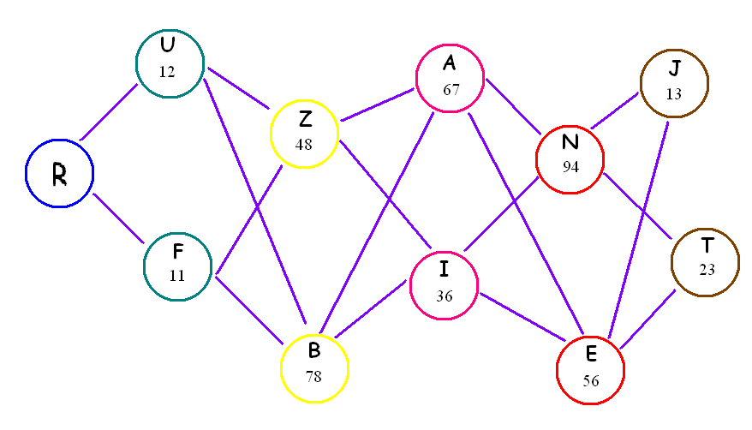

Polipos feladvány:



528,23+236,01=
1023,05-853,67=
904,79-204,57=
102,63+32,4+53,31=
794,34-137,43=
10,2+502,13+3,57=

