Telecommunication, internet
4th quarter 2009
At the end of 2009 the number of mobile phone subscriptions was 11.8 million. Three quarters of the duration of phone calls originated from calls initiated from mobile phones. While cable telephony became more and more popular, the number of fixed lines decreased further. The number of internet subscriptions increased by 472 thousand in 1 year, and it almost exceeded 2.8 million. 57 percent was connected to broadband technology (xDSL and cable television), this service field expanded by 4 percent since the end of 2008. Wireless technology, whose number already reached one million, increased by 50 percent in one year. One third of the total number of subscriptions was connected to mobile internet.
The number of mobile phone subscription decreased by 432 thousand (3.5%) in one year. At the end of 2009 the number of subscriptions was 11.8 million. Within it the number of monthly plan subscriptions increased, but it could not compensate for the 802 thousand drop of subscriptions in the prepaid plan segment. The number of mobile subscriptions was 118 per 100 capita.
Although more and more businesses (among other cable television or internet providers) offer fixed lines and call service, at the end of 2009 – based on preliminary data – 3.1 million fixed trunk lines, that is, 55 thousand fewer than a year before, were in operation, 15% of it was cable television, 17% was ISDN. On the last day of the period the number of fixed trunk lines was 31 per 100 capita. The number of calls initiated from fixed lines decreased by 9% and their duration by 6% compared to the 4th quarter of 2008. The drop was caused by the increase in mobile traffic and the spreading of free but immeasurable internet telephony possibilities.
- The duration of calls per one fixed line was 459 minutes (without data-type traffic), which is less by 3% than in the same period of the previous year.
- The average duration of calls initiated in fixed-line networks was 3.2 minutes, which is the same as the data without internet calls.
- Regarding the whole year the drop in the number and the duration of the calls was 10% and 9%, respectively.
Due to the decrease in prices and the spread of plans that often contain a considerable free period and free calls within the network as well, the subscribers initiate fewer calls but these calls are longer than in the case of mobile phones. Three quarters of the total duration of phone calls is related to calls initiated from mobile equipments. The ratio of both the number and duration of internet-related calls initiated from fixed line decreased to nearly one half compared to the year of 2008.
The expansion of the internet market continued: although there are fewer service providers, the number of subscribers increased.
- In the 4th quarter of 2009 the number of internet service providers was 357, 46 less than one year before.
- The market is concentrated, 18 businesses own 90% of the subscriptions.
- At the end of 2009 the number of internet subscriptions was nearly 2.8 million, this is greater by one fifth than in the same period of 2008.
The development of the internet market – besides the spread of more and more up-to-date technologies – is due to the sharpening competition between the service providers. While the expansion of the two most important types of fixed-line internet slowed down, the wireless segment increased by 50% in one year. The enormous change is largely attributed to mobile internet, which is becoming more and more affordable and whose increase was 63%.
Within the total number of subscriptions the share of the dial-in segment (switched line and ISDN combined) did not change significantly, cable television and xDSL decreased by 3% and 6%, respectively, but the wireless segment increased by 8 percent compared to the end of 2008.
In the 4th quarter the net revenue from internet services exceeded 34.9 thousand million HUF, which was 5% less at current price than one year before due to subscriber discounts (for example free months) and the decrease in prices. The total net revenue in 2009 was almost the same as in 2008.
Number of fixed lines and mobile subscriptions at the end of each period
Year,  quarter |  | Number of live fixed trunk lines, thousand |  | Number of mobile subscriptions, thousand |  | Number of fixed trunk lines per 100 capita | Number of mobile subscriptions per 100 capita
 |  | total | ISDN thereof | total | prepaid card thereof | Number of fixed trunk lines per 100 capita | Number of mobile subscriptions per 100 capita
2008 | 1st | 3247 | 574 | 11232 | 6966 | 32.3 | 111.9
2008 | 2nd | 3207 | 574 | 11540 | 7163 | 32.0 | 115.0
2008 | 3rd | 3155 | 571 | 11771 | 7227 | 31.4 | 117.3
2008 | 4th | 3115 | 559 | 12224 | 7486 | 31.1 | 121.9
2009 | 1st | 3093 | 546 | 12112 | 7314 | 30.9 | 120.9
2009 | 2nd | 3090 | 533 | 11889 | 7039 | 30.8 | 118.7
2009 | 3rd | 3078 | 523 | 11783 | 6845 | 30.7 | 117.6
2009 | 4th | 3060 | 510 | 11792 | 6683 | 30.6 | 117.8
Changes in the number of telecommunication services from 1990 to 2009
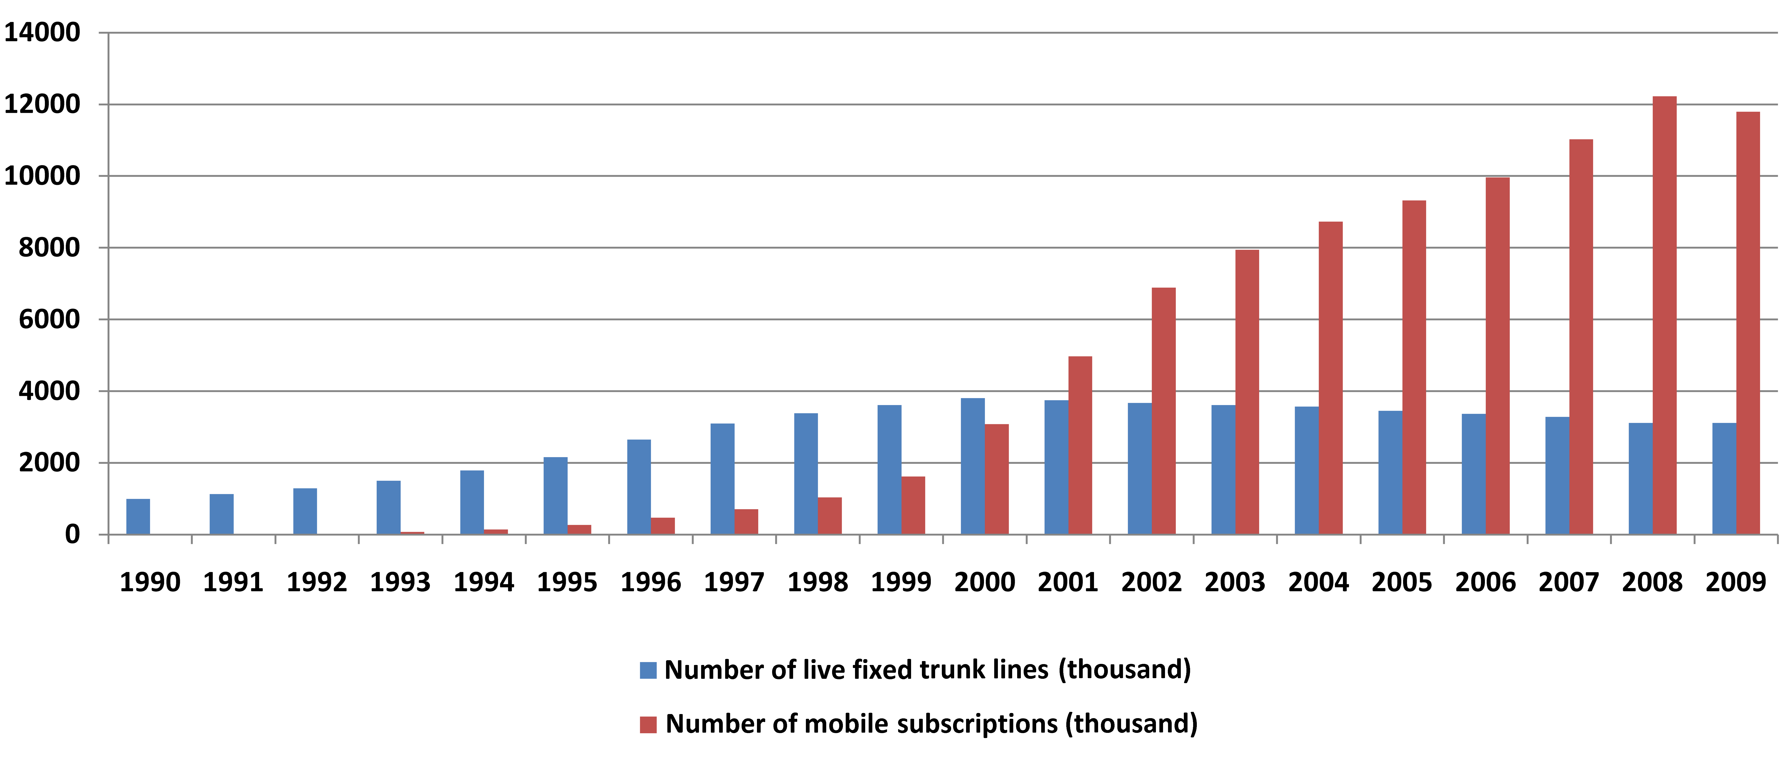

The different coupon- or daily ticket-based internet users, who do not require subscription agreement or monthly fee are excluded from the mobile internet subscriptions displayed here. In the 1st quarter of 2009 the definition of mobile internet (based on the agreement between mobile service providers) changed compared to the previous periods.
E.g. GPRS EDGE, 3G/HSDPA based internet services. In the 1st quarter of 2009 the definition of mobile internet subscription changed based on the agreement between mobile service providers. Subscription means the number of SIM cards for which on the last day of the given calendar quarter an internet service (prepaid and postpaid) containing at least 10 Mbyte of data traffic and having a monthly price greater than zero HUF was active. If for a SIM card several plans were active, then these should be indicated as a single SIM.
The different coupon- or daily ticket-based internet users, who do not require subscription agreement or monthly fee are excluded from the mobile internet subscriptions displayed here. In the 1st quarter of 2009 the definition of mobile internet (based on the agreement between mobile service providers) changed compared to the previous periods.

